**OOP ASSIGNMENT 1**

**TO**

**ATIR RAZA**

**BY**

**MUHAMMAD WASIF**

**L1F24BSDS0026**

**Student.h:**

#pragma once

#include <iostream>

using namespace std;

class Student {

private:

string name;

int age, rollno;

double gpa;

public:

Student(); //Default Constructor

Student(string n, int a=15, int rol=33, float g=3.1); //Declare Default argument

Student(string na, int ag, int roll, double gp); //Declare Parameter Constructor

~Student(); //Destructor

void show(); //Function for Show

};

**Student.cpp:**

#include "Student.h"

Student::Student() { //initialize defualt values

name = "Danial";

age = 19;

rollno = 45;

gpa = 3.9;

}

Student::Student(string n, int a, int rol, float g ) { //Initilize Default Arguments

name = n;

age = a;

rollno = rol;

gpa = g;

}

Student::Student(string na, int ag, int roll, double gp) { //Initialize Parameter Constructor

name = na;

age = ag;

rollno = roll;

gpa = gp;

}

void Student::show() {

cout << "Name: " << name << ", Age: " << age << ", Rollno: " << rollno

<< ", GPA: " << gpa << ", ";

if (gpa >= 3.8 && gpa <= 4.0) {

cout << "Grade: A" << endl;

}

else if (gpa >= 3.0 && gpa <= 3.8) {

cout << "Grade: B" << endl;

}

else if (gpa >= 2.5 && gpa <= 3.0) {

cout << "Grade: C" << endl;

}

else if (gpa >= 2.0 && gpa <= 2.5) {

cout << "Grade: D" << endl;

}

else {

cout << "Grade: F" << endl;

}

}

Student::~Student() {

cout << "Destructor deleted Object!" << endl;

}

**main.cpp:**

#include "Student.h"

int main() {

Student s1;

Student s2("Numan", 30);

Student s3("Ramish", 22, 26, 2.7);

s1.show();

s2.show();

s3.show();

return 0;

}

**Outputs:**

**Executed:**

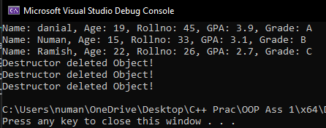

**Executed with default Argument:**

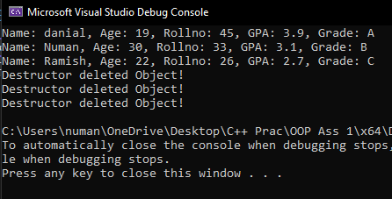

**Repository link**

<https://github.com/wasifasif678-dotco/OOP-Assignment-1-.git>